- Install Terraform on your PC

Step 1: Download Terraform

1. Go to:
👉 [https://developer.hashicorp.com/terraform/downloads](https://developer.hashicorp.com/terraform/downloads)
2. Download the **Windows (amd64)** ZIP file.

Step 2: Extract Terraform

1. Extract the ZIP file
You’ll get `terraform.exe`

Example location:

```
C:\terraform\
```
Step 3: Add Terraform to PATH

1. Press **Windows + R** → type:
```
sysdm.cpl
```
2. Go to **Advanced** tab → **Environment Variables**
3. Under **System variables**, select `Path` → **Edit**
4. Click **New** → add:

C:\terraform

- Click OK → OK → OK

Step 4: Verify Installation

Open a **new Command Prompt / PowerShell** and run:

terraform -version

You should see something like:

Terraform v1.x.x

2) Execute all the templates shown in video.

Open visual studio --> create a folder terraform --> create a new file “main.tf”
“.tf ” is extention of terraform resource files
“Main.tf” is the configuration file .
Go to extensions --> search for hashi corp terraform --> install it

Written a basic script .

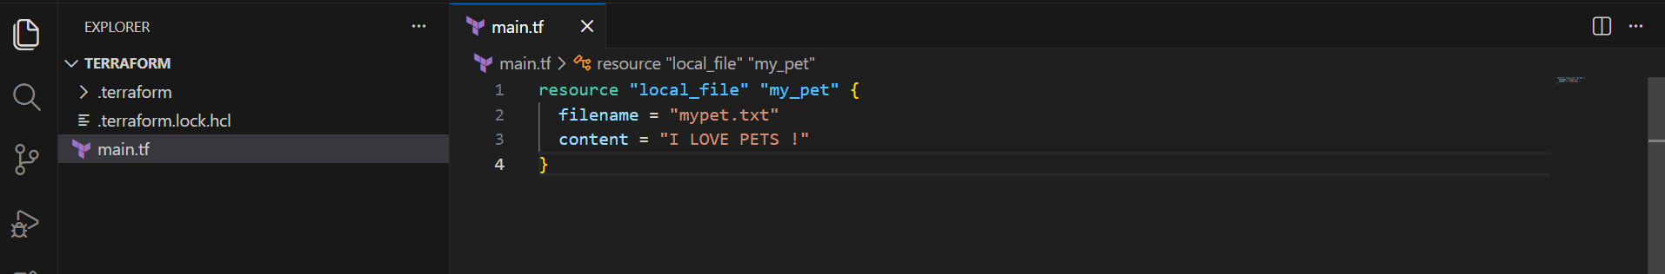

We get providers from “terraform registry”

Here ,. Resource --> block
Local --> provider
File --> type of resource
My_pet --> name for terraform
Filename and content --> attributes .

After this open terminal , run the command ‘terraform init ‘

It Initialises the directory and downloads the necessary plugins or dependencies (APIs) required to communicate with the specific providers.

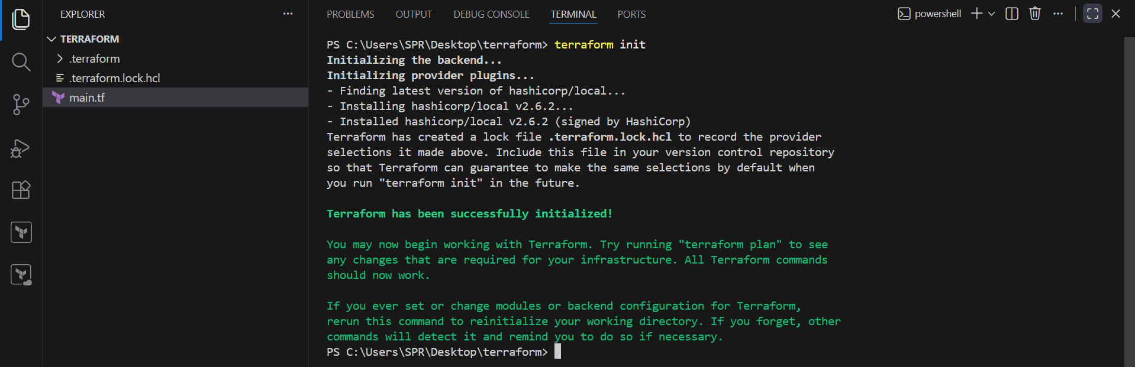

Run the command ‘terraform plan’

It shows exactly what changes will be made (additions, modifications, or destructions) without actually executing them.
◦ Symbols: + indicates creation, - indicates destruction, and ~ indicates modification,.

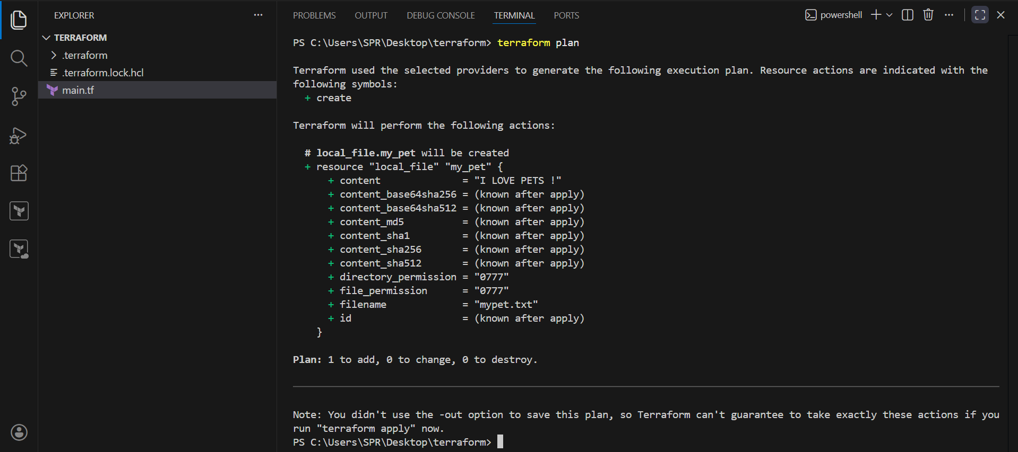

Run the command ‘terraform apply’

It executes the configuration to provision the resources

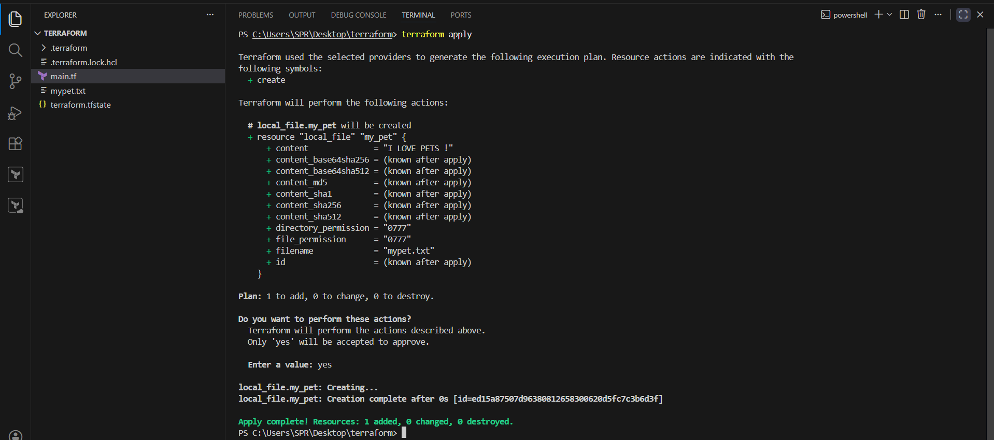

We can see the file created.

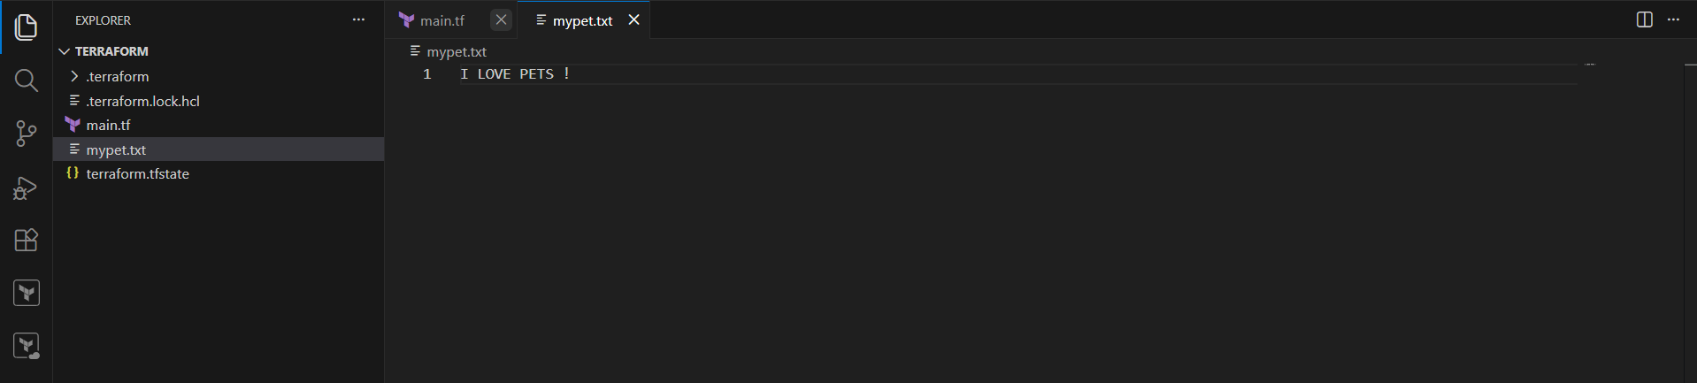

Now I changed the content “I love pets!” to “I hate pets”

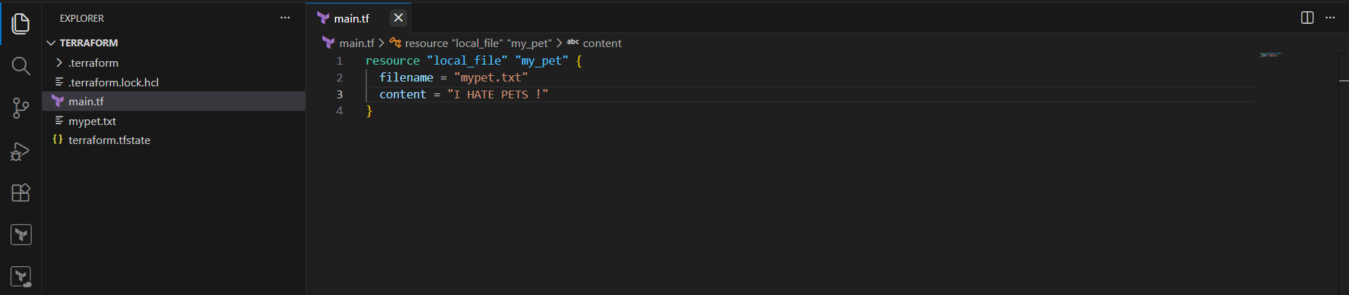
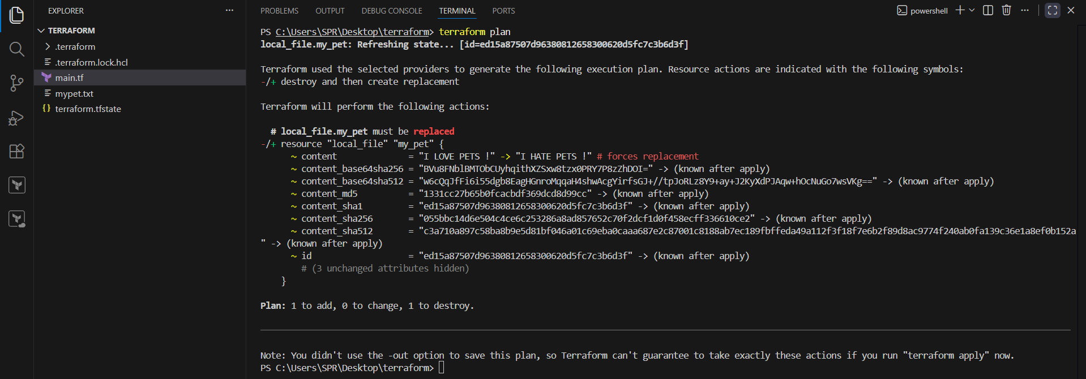
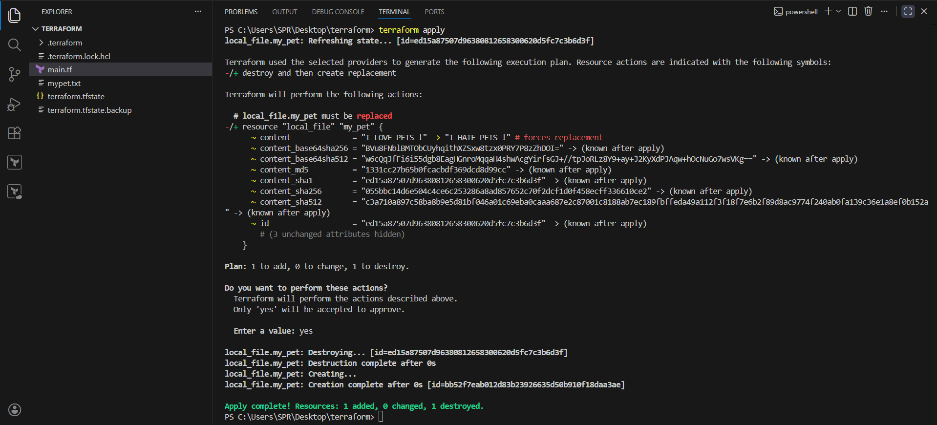

We can check the file as updated.

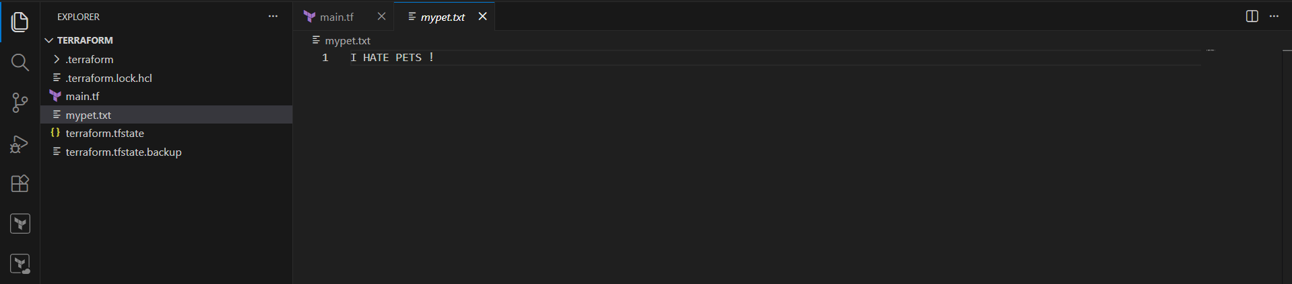

Adding one more provider “random” to create a unique name for our terraform file.
Save the file “main.tf”.

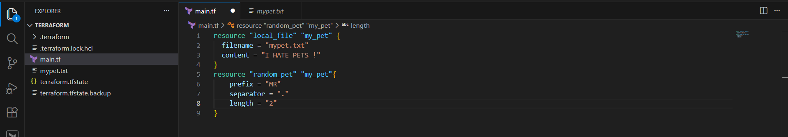

As we written new provider , we need to init again , so that dependencies gets downoaded for provider “random”

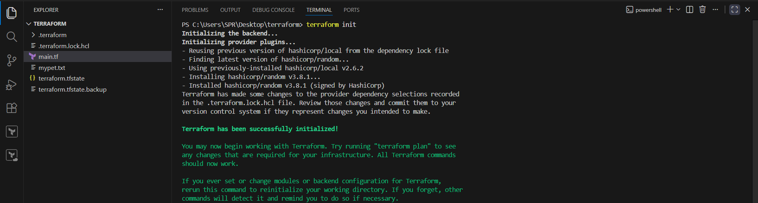
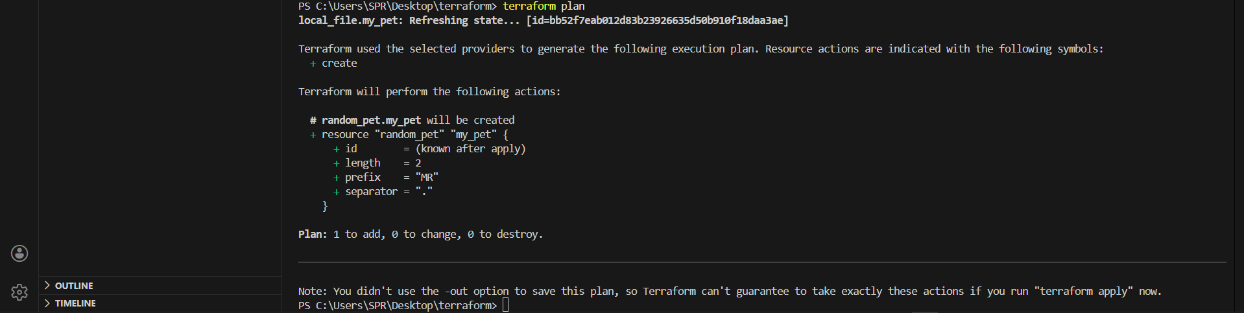

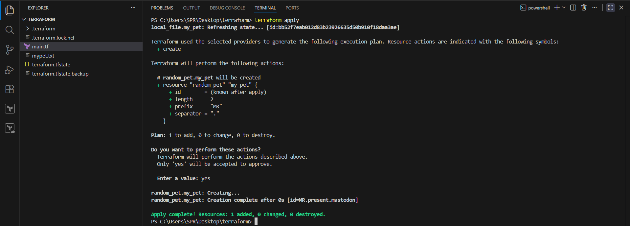

We can see a random name is created .
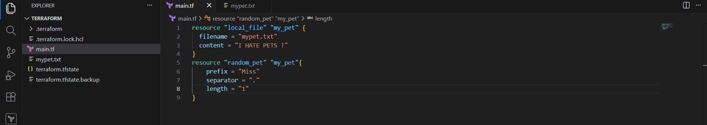
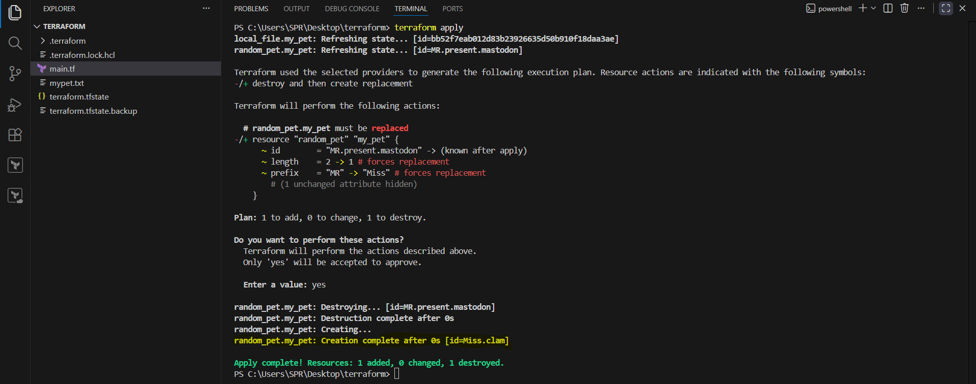
To automatically reorganises the code for proper syntax and spacing, the command is “terraform fmt”

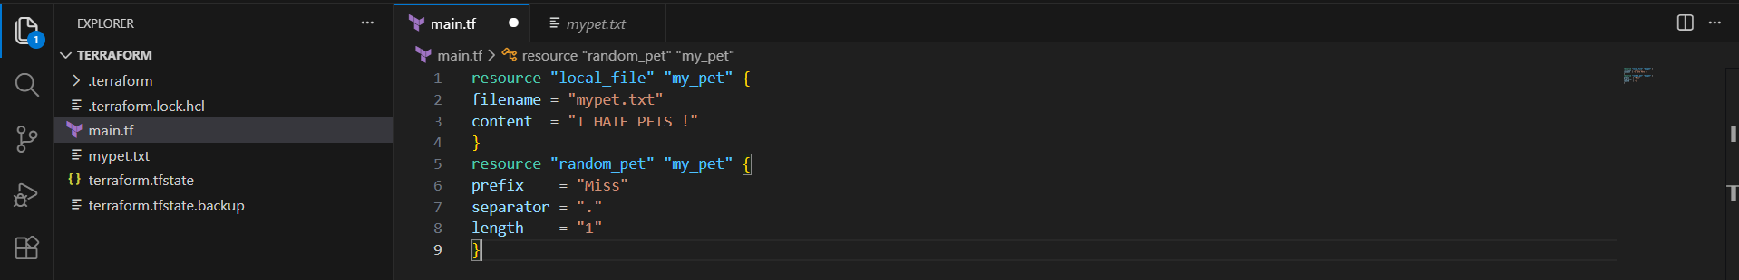

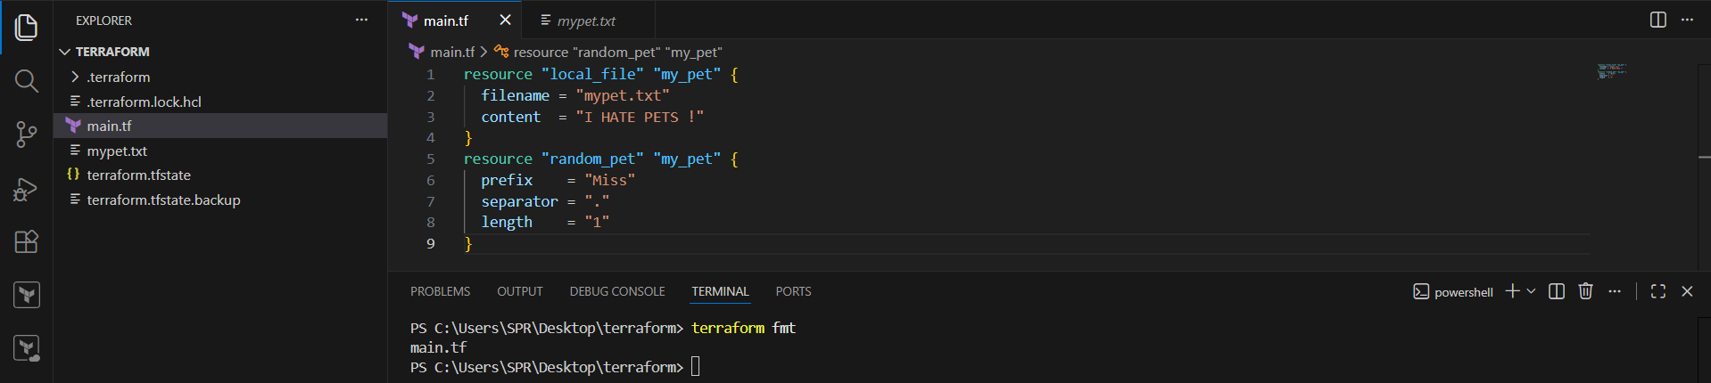

To delete the file (or) resource managed by configuration file , the command is “terraform destroy”.

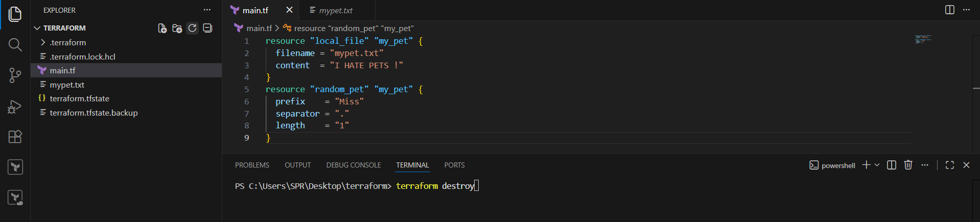

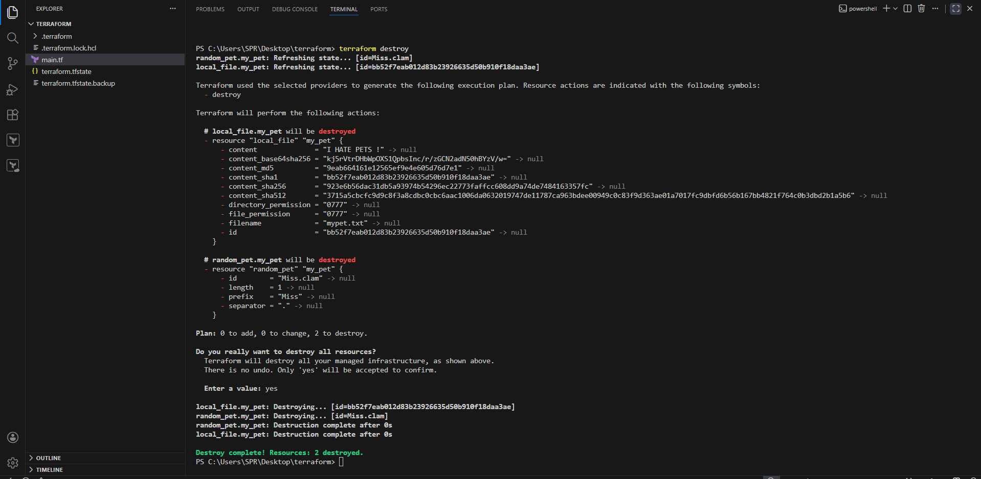

3) Note down below points,
Terraform Init
Terraform Plan
Terraform Apply
Terraform Provider

• terraform init: Initialises the directory and downloads the necessary plugins or dependencies (APIs) required to communicate with the specific providers,.

• terraform plan: Acts as a "dry run" or blueprint. It shows exactly what changes will be made (additions, modifications, or destructions) without actually executing them.
◦ Symbols: + indicates creation, - indicates destruction, and ~ indicates modification,.

• terraform apply: Executes the configuration to provision the resources,.

• terraform destroy: Deletes all resources managed by the configuration file.

• terraform fmt: Automatically reorganises the code for proper syntax and spacing.

• Providers: These are packages of API calls that allow Terraform to communicate with resources, whether they are local files or cloud-based services like AWS EC2,.

Providers are in three categories
1) Official --> provided by Hashicorp
2) Partner --> third party vendors
3) Community --> individual
Common providers :

aws → Amazon Web Services
azurerm → Microsoft Azure
google → Google Cloud
kubernetes → Kubernetes clusters
github → GitHub repos & settings
helm → Helm charts

A provider defines :

Resources (e.g., aws_instance, azurerm_vm)
Data sources (e.g., aws_ami, google_compute_image)
Authentication methods
API logic

- Integrate a sample Terraform template in Jenkins.

Step by step implementation :

## step1 : In jenkins server , install terraform

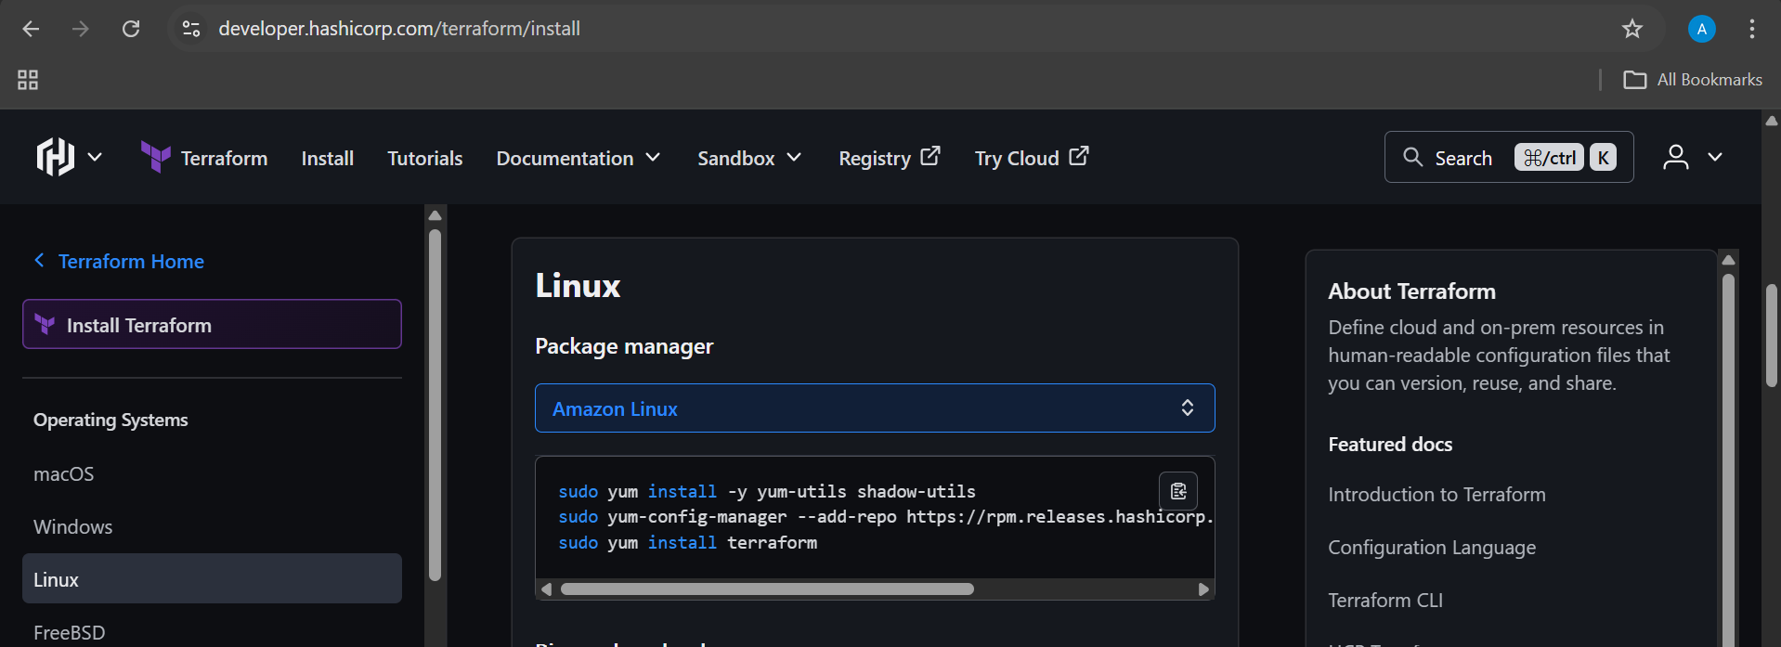

sudo yum update -y
sudo yum install -y yum-utils shadow-utils
sudo yum-config-manager --add-repo https://rpm.releases.hashicorp.com/AmazonLinux/hashicorp.repo
sudo yum install terraform

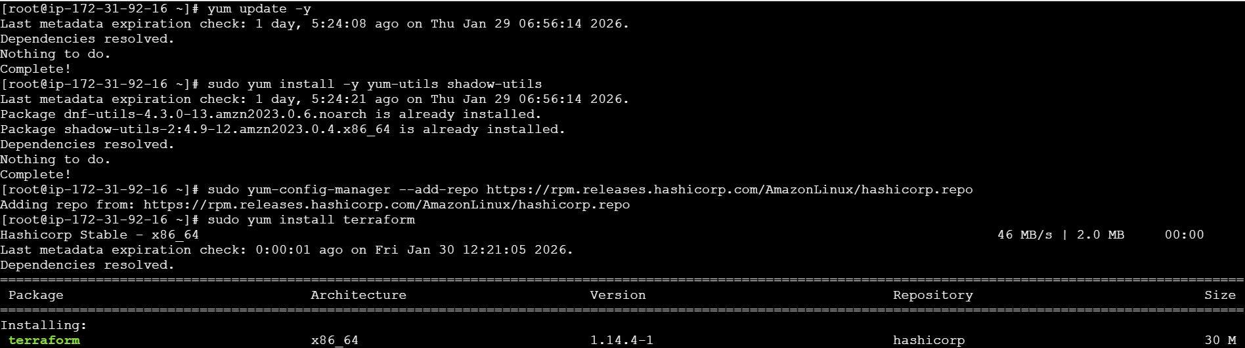
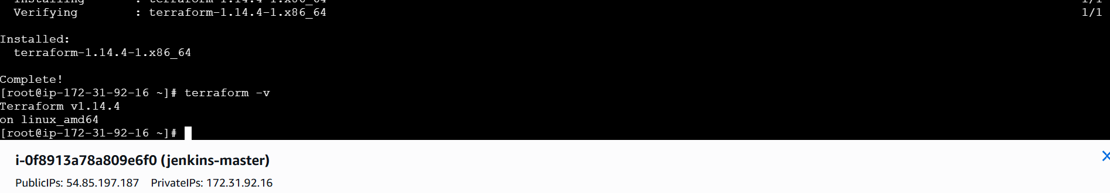

Verify jenkins is active or restart jenkins.

## step2 : In jenkins gui , download “terraform” plugin.

Manage jenkins --> plugins --> available plugins
Search for “terraform” and install

Add terraform under tools :
Manage jenkins --> tools --> add terraform

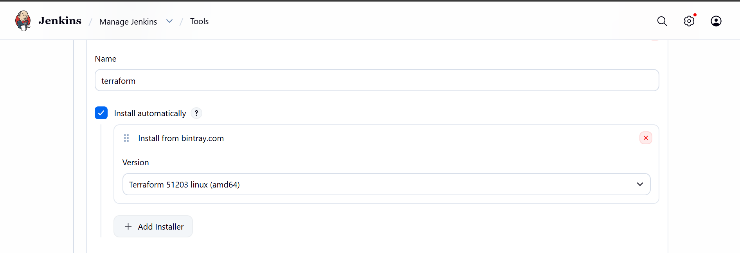
Save and exit.

## step3 : create a repository named “terraform” with README configurations.

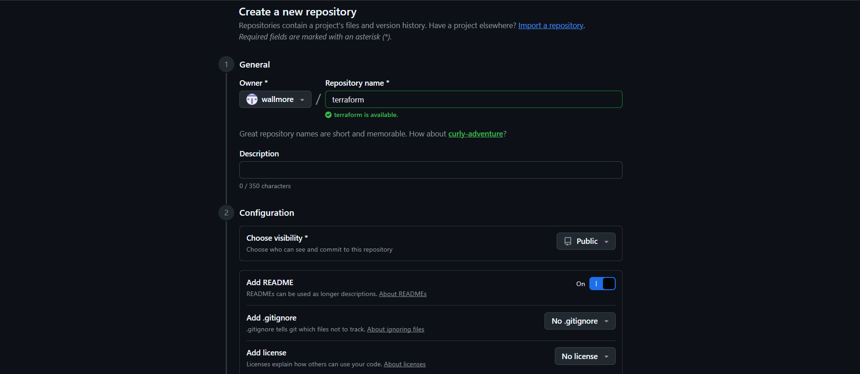

In repository create a sample script to execute as file name “main.tf”

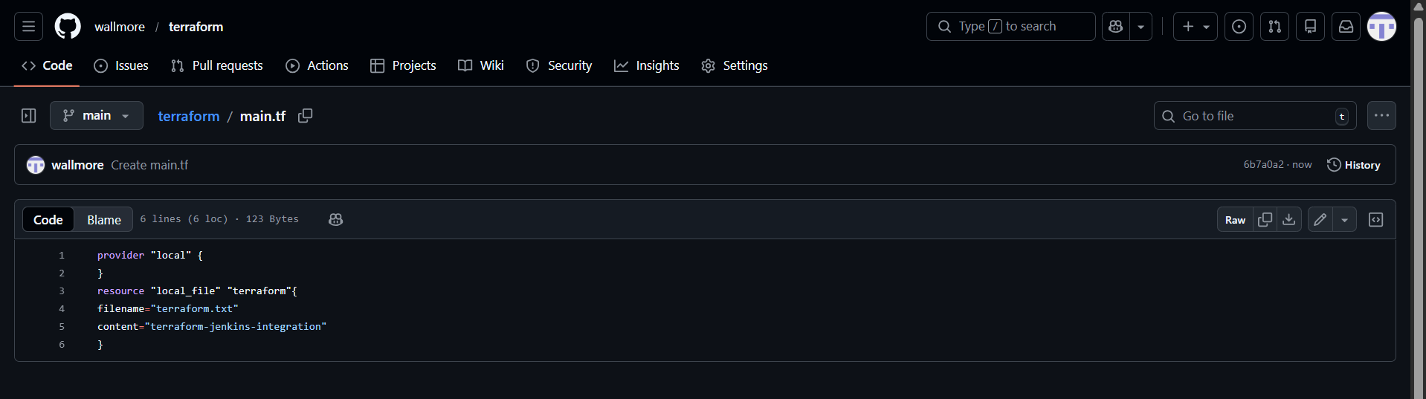

## step4 : create a pipeline job , and write a script for terraform .
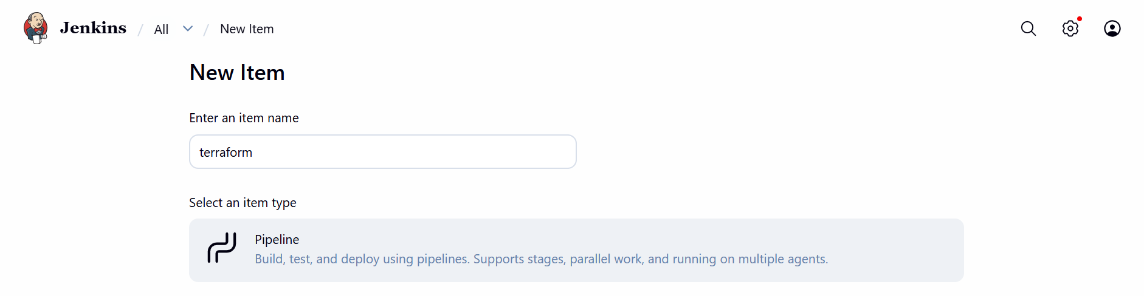

Pipeline script :

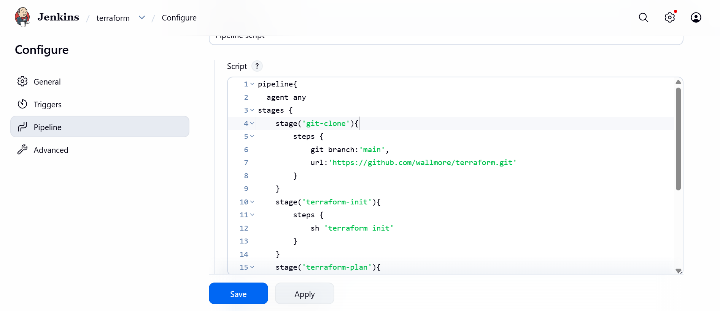

pipeline{
agent any
tools {
terraform 'terraform'
}
stages {
stage('git-clone'){
steps {
git branch:'main',
url:'https://github.com/wallmore/terraform.git'
}
}
stage('terraform-init'){
steps {
sh 'terraform init'
}
}
stage('terraform-plan'){
steps {
sh 'terraform plan'
}
}
stage('terraform-apply'){
steps {
sh 'terraform apply -auto-approve'
}
}
}
}

## step5 : build the job
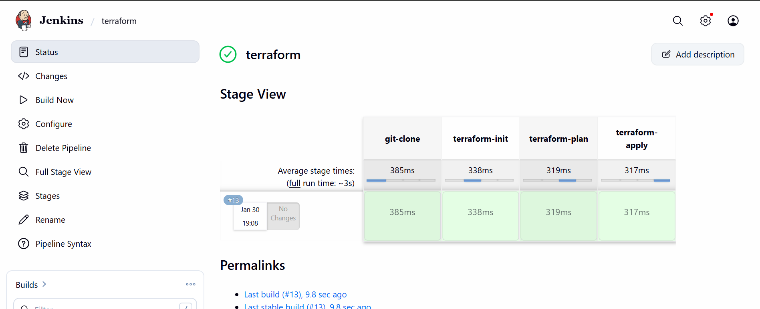

Terraform integrated with jenkins.

